 

CS-114 Fundamentals of Programming (2+1)

DE-41 EE Semester 1

Fall 2019

**LAB REPORT # 09**

|  |  |
| --- | --- |
| **Submitted by** | **Roll No** |
| Ayesha Javaid | 285151 |
| Syndicate A |  |

Instructor In-charge: Dr. Saad Rehman

DEPARTMENT OF COMPUTER & SOFTWARE ENGINEERING

College of Electrical and Mechanical Engineering (CEME)

National University of Sciences and Technology (NUST)

**Lab Number: 9**  
**Lab Title: Strings**  
**Aim:**

To have better knowledge about **strings** and how to use them.

**Topic(s) covered:**

**Strings.**

**(Tasks starting from next page)**

**Task 1:**

1. **Try these functions of C style string**  
   strcat(str1,str2): Appending the string

strcmp(str1,str2): Returns -ve value if str1 is less than str2;0 if str1 is equal to str2; and >0 (+ve value) if str1 is greater than str2

strcpy(str1,str2): Replace the content

strlen(str1): Gives the length of the string

**code:**

#include<iostream>

#include<cstring>

using namespace std;

int main()

{

char str1[12] = "Hello";

char str2[] = "World";

int len;

cout << "strcmp(str1,str2) :" << strcmp(str1, str2) << endl;

cout << " strcat_s(str1, str2): " << strcat_s(str1, str2) << endl;

strcpy_s(str1, str2);

cout << "strcpy (str1,str2) : " << strcpy_s(str1, str2) << endl;

len = strlen(str1);

cout << "strlen(str1) : " << len << endl;

system("pause");

return 0;

}

**Output:**

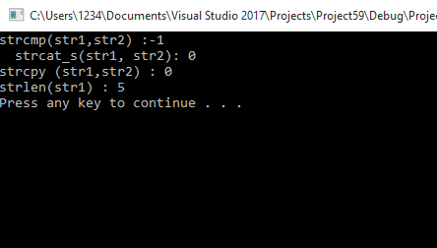

**Task 2:**

1. Write a program using **C-string** that capitalizes each character of the string. For instance, if the string argument is “hello” the program should manipulate the string so it contains “HELLO”.

**Code:**

#include<iostream>

using namespace std;

int main()

{

char str[] = " nust eme ";

for (int i = 0; i < 9; i++)

{

str[i] = str[i] - 32;

cout << str[i] << endl;

}

system("pause");

return 0;

}

**Output:**

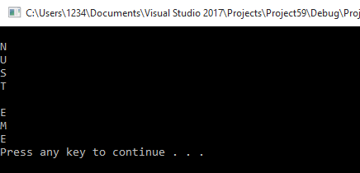

**Task 3:**

1. Write a program that displays the contents of **C-string** backward. For instance, if the string argument is “Gravity” the program should display “ytivarG”.

**Code:**

#include<iostream>

using namespace std;

int main()

{

char str[] = " Hi";

int i;

for (i = 3; i > 0; i--)

{

cout << str[i] << endl;

}

system("pause");

return 0;

}

**Output:**

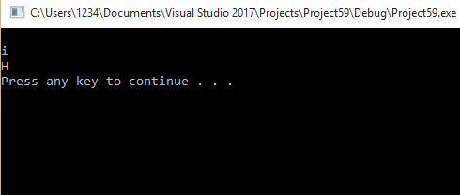

**TASK 4:**  
**RUN THE FOLLOWING CODE AND SHARE THE OUPUT**  
#include<iostream>

#include<string>// including string library

usingnamespacestd;

intmain()

{

string str1 = "Hello";

string str2 = "World";

string str3;

intlen;

// copy str1 into str3

str3 = str1;

cout<<"str3 : "<< str3 <<endl;

// concatenates str1 and str2

str3 = str1 + str2;

cout<<"str1 + str2 : "<< str3 <<endl;

// total length of str3 after concatenation

len = str3.size();

cout<<"str3.size() : "<<len<<endl;

return 0;

}  
**OUTPUT:**

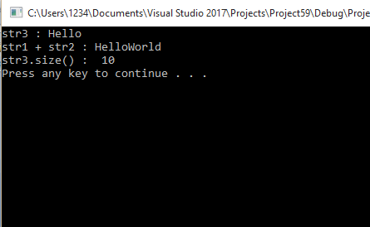

**TASK 5**  
Run the following code, show your output and **share your understanding** in descriptive form regarding **cin** and **getline(cin, str**)

**Code:**

#include<iostream>

#include<string>

Using namespace std;

int main()

{

string str1, str2;

cout << "Enter your Full Name (using cin command)" << endl; //e.g. Ali Hassan

cin >> str1;

cin.ignore(numeric_limits<streamsize>::max(), '\n'); //clear buffer before taking newline

cout << "Enter your Full Name (using getline function)" << endl;

getline(cin, str2);

cout << "Full Name (using cin command):" << str1 << endl;

cout << "Full Name (using getline function):" << str2 << endl;

return 0;

}

**Output:**

